FABRICATION OF MOTORIZED HARVESTING MACHINE FOR AGRICULTURAL PURPOSE

The project aims at designing a system which makes the paddy cutter based motor running through solar energy.

In this project, harvesting of rice and wheat using crop cutter was evaluated. Results showed that the field capacity of crop cutter was 2.44 times higher than the manual operation. The labor requirement was 32.74 and 149.25 man-hr/ha for crop cutter and manual operation, respectively. In case of wheat, the field capacity of crop cutter was 2.23 times greater than manual harvesting and labor involvement was 23.20 and 115.74 man -hr/ha for crop cutter and manual operation, respectively.

The project provides learning’s on the following advancements:

- Solar panel characteristics.
- Charging circuit.

The major building blocks of this project are:
- Solar panel.
- Charging circuit.
- Battery
- Paddy cutter mounted on motor

Block Diagram:

Existence

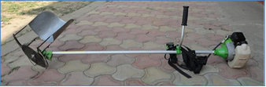

Propose

